Test Case: tc003_SPX_Dev5_Crear_Requisicion_Spot_Tipo_Cobro_CC_Urgent
Step 1 - Enter username and password and click to button Enter : Credentials Entered
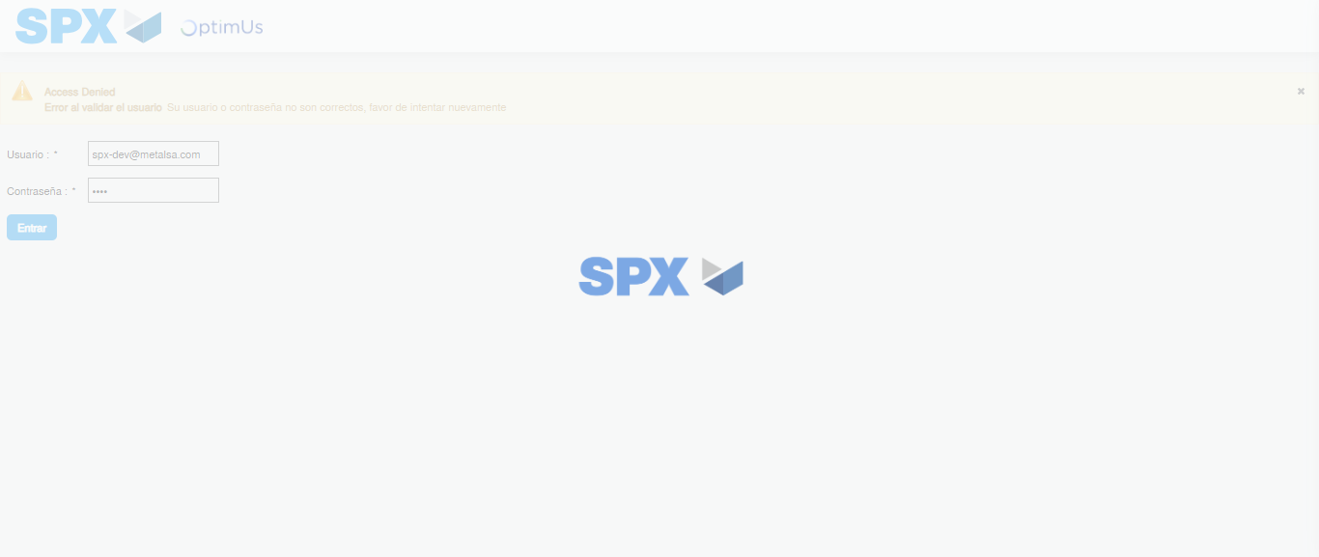Image file-name: QC_Testing-tc003_SPX_Dev5_Crear_Requisicion_Spot_Tipo_Cobro_CC_Urgent-1785961439201

Step 2 - Select to UEN and Access to Spot Buy Requisitions : UEN Correctly selected and Correct access
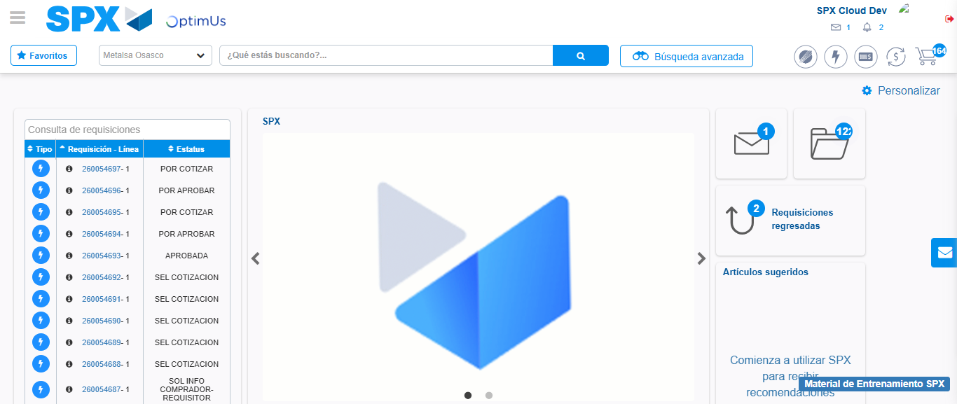Image file-name: QC_Testing-tc003_SPX_Dev5_Crear_Requisicion_Spot_Tipo_Cobro_CC_Urgent-1785961464009

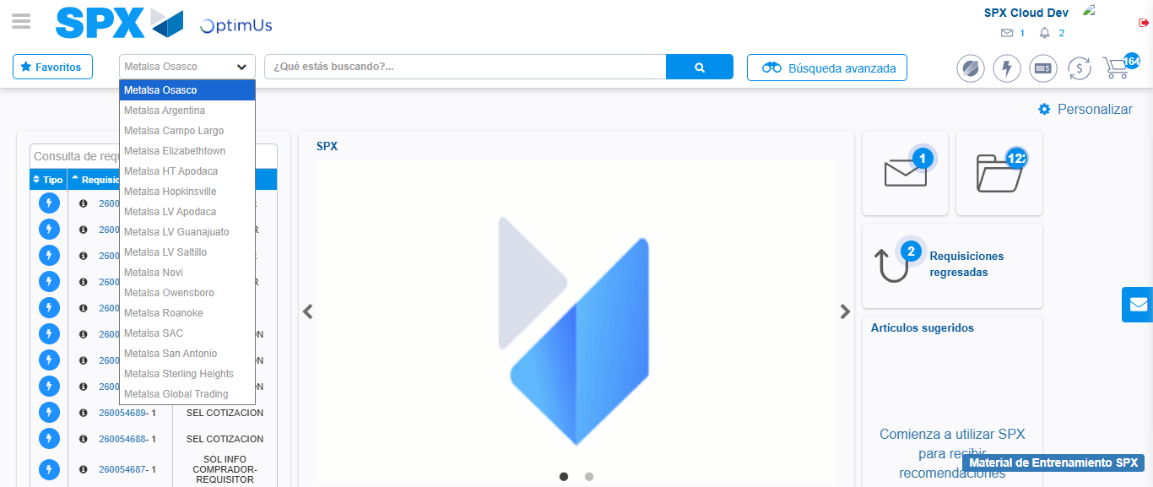Image file-name: QC_Testing-tc003_SPX_Dev5_Crear_Requisicion_Spot_Tipo_Cobro_CC_Urgent-1785961466585

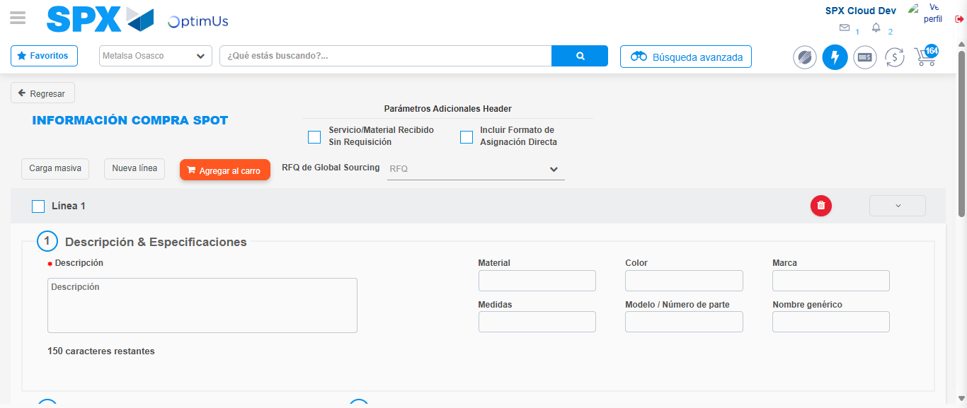Image file-name: QC_Testing-tc003_SPX_Dev5_Crear_Requisicion_Spot_Tipo_Cobro_CC_Urgent-1785961471232

Step 3 - Data Capture Spot Buy Requisition: Data captured correctly
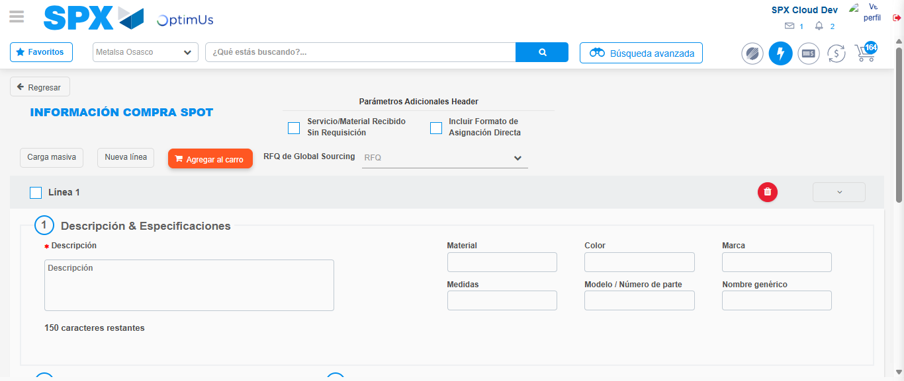Image file-name: QC_Testing-tc003_SPX_Dev5_Crear_Requisicion_Spot_Tipo_Cobro_CC_Urgent-1785961471494

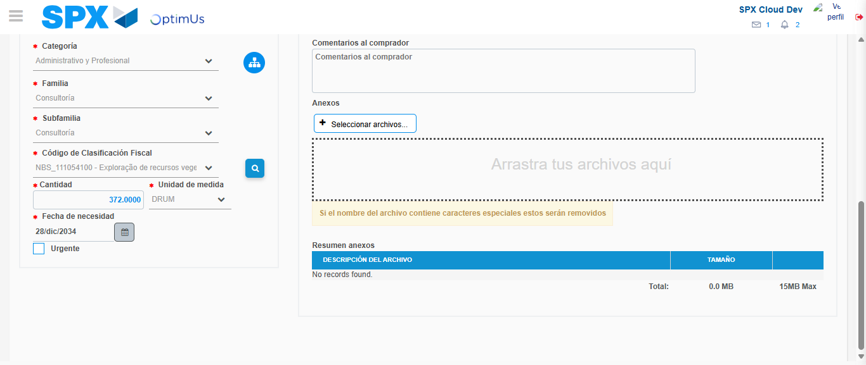Image file-name: QC_Testing-tc003_SPX_Dev5_Crear_Requisicion_Spot_Tipo_Cobro_CC_Urgent-1785961487060

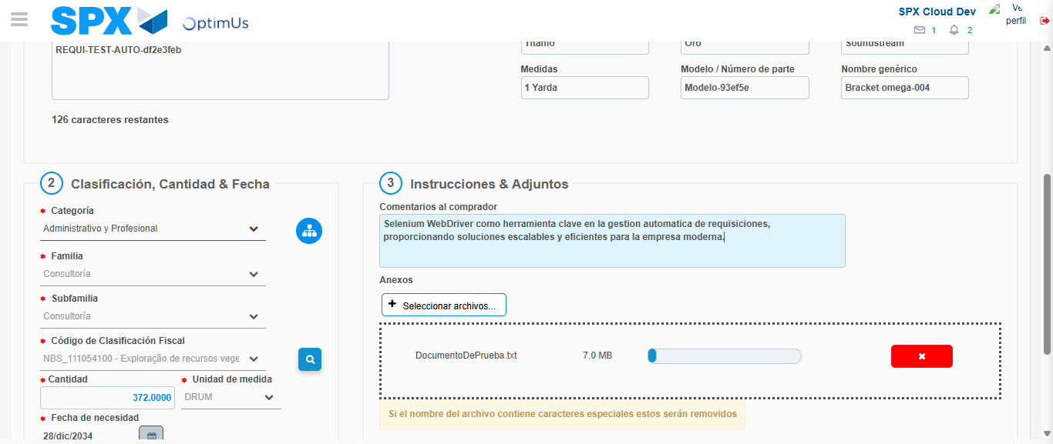Image file-name: QC_Testing-tc003_SPX_Dev5_Crear_Requisicion_Spot_Tipo_Cobro_CC_Urgent-1785961487787

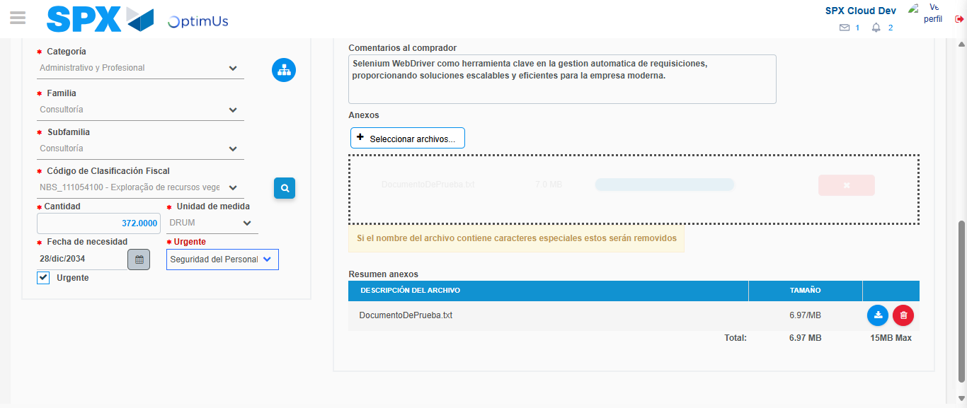Image file-name: QC_Testing-tc003_SPX_Dev5_Crear_Requisicion_Spot_Tipo_Cobro_CC_Urgent-1785961491505

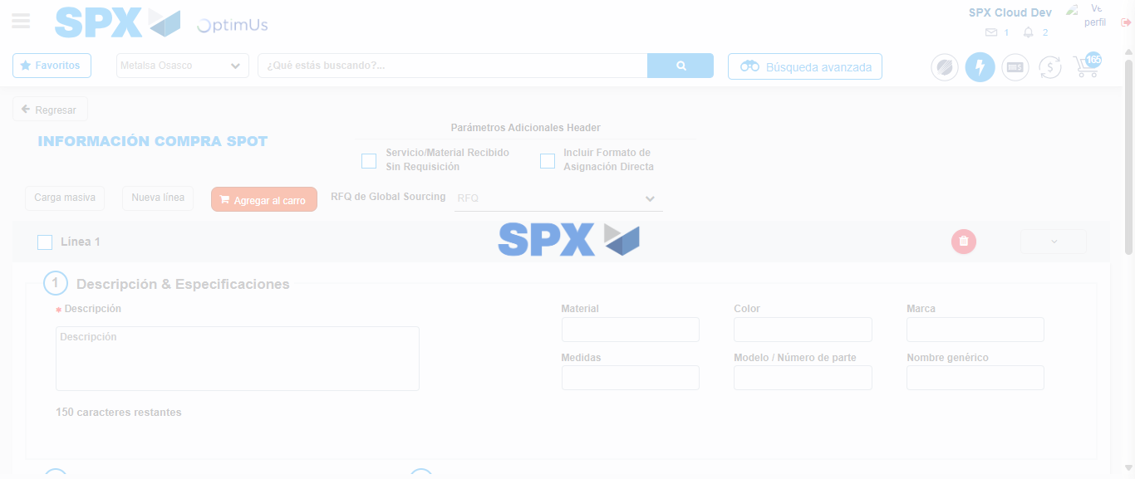Image file-name: QC_Testing-tc003_SPX_Dev5_Crear_Requisicion_Spot_Tipo_Cobro_CC_Urgent-1785961504124

Step 7 - Return to Main Page SPX : Return to Main Page SPX
Image file-name: QC_Testing-tc003_SPX_Dev5_Crear_Requisicion_Spot_Tipo_Cobro_CC_Urgent-1785961464009

Image file-name: QC_Testing-tc003_SPX_Dev5_Crear_Requisicion_Spot_Tipo_Cobro_CC_Urgent-1785961466585

Image file-name: QC_Testing-tc003_SPX_Dev5_Crear_Requisicion_Spot_Tipo_Cobro_CC_Urgent-1785961471232

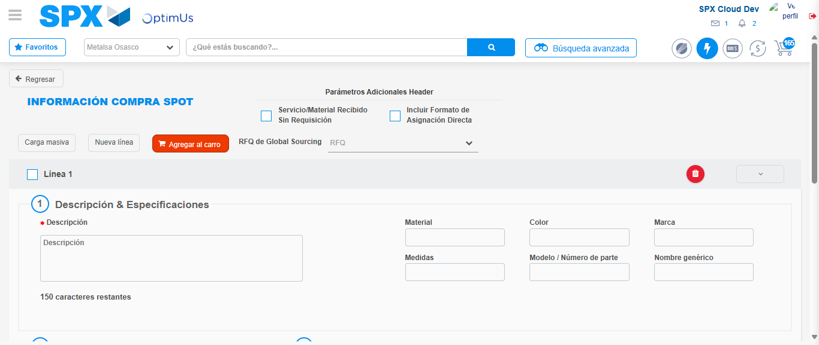Image file-name: QC_Testing-tc003_SPX_Dev5_Crear_Requisicion_Spot_Tipo_Cobro_CC_Urgent-1785961506389

Image file-name: QC_Testing-tc003_SPX_Dev5_Crear_Requisicion_Spot_Tipo_Cobro_CC_Urgent-1785961506578

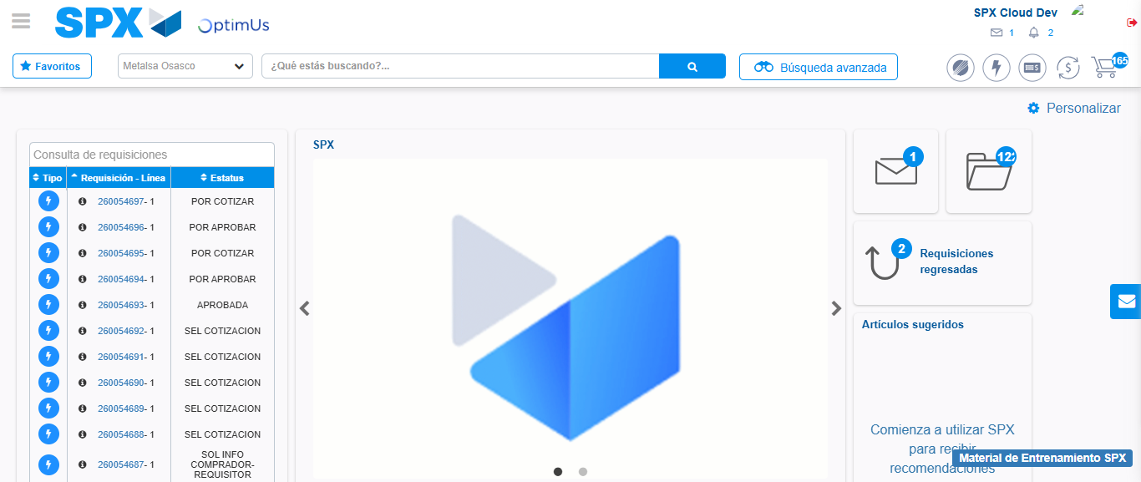Image file-name: QC_Testing-tc003_SPX_Dev5_Crear_Requisicion_Spot_Tipo_Cobro_CC_Urgent-1785961527676

Step 8 - Log Out : Log Out SPX
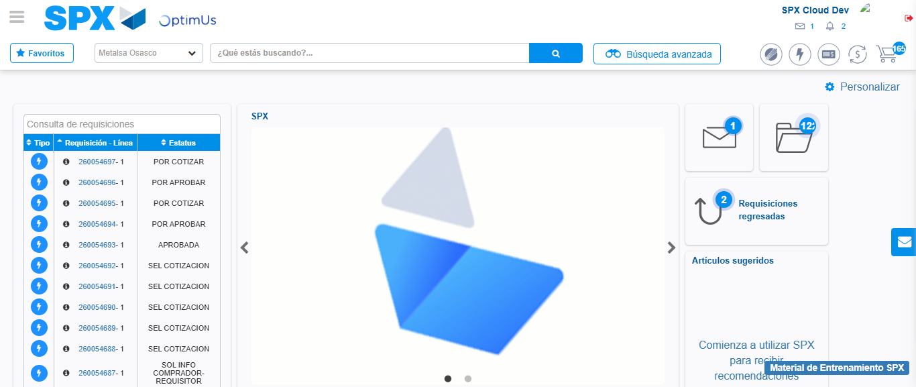Image file-name: QC_Testing-tc003_SPX_Dev5_Crear_Requisicion_Spot_Tipo_Cobro_CC_Urgent-1785961527954

